**Task 14: Debug a failing Azure DevOps pipeline with errors in environment variable configuration.**

**Expected Output**: Fixed pipeline.yml, screenshots of successful pipeline execution.

* **Failed pipeline.yaml**

trigger:

- main

pool:

name: 'self-hosted-server'

variables:

keyVaultName: "mahesh-key"

secretName: "maheshsecret"

stages:

- stage: Deploy

displayName: deploy application

jobs:

- job: RetrieveSecrets

displayName: retrieve secrets and deploy Node.js app

steps:

- task: AzureKeyVault@2

inputs:

azureSubscription: 'maheshkeyvaultconnection-v2'

KeyVaultName: $(keyVaultName)

SecretsFilter: $(secretName)

- script: |

echo "retrieving secret"

if [ -z "$(maheshsecret)" ]; then

echo "##vso[task.logissue type=error]Secret retrieval failed: maheshsecret is empty"

exit 1

fi

echo "##vso[task.setvariable variable=MY_SECRET;issecret=true]$(maheshsecret)"

displayName: 'set secret as variable'

- task: UseNode@1

inputs:

version: '16.x'

displayName: 'install Node.js'

- script: |

echo "deploying Node.js app"

KEYVAULT_NAME=$(keyVaultName) \

SECRET_NAME=$(secretName) \

MY_SECRET=$(MY_SECRET) \

nohup node server.js > app.log 2>&1 &

displayName: 'start Node.js application'

- script: |

echo "checking if Node.js app is running"

sleep 5

ps aux | grep node

sudo netstat -antp | grep 3000 || echo "Port 3000 is not listening"

displayName: 'verify application running'

* **screenshots of failed pipeline execution**

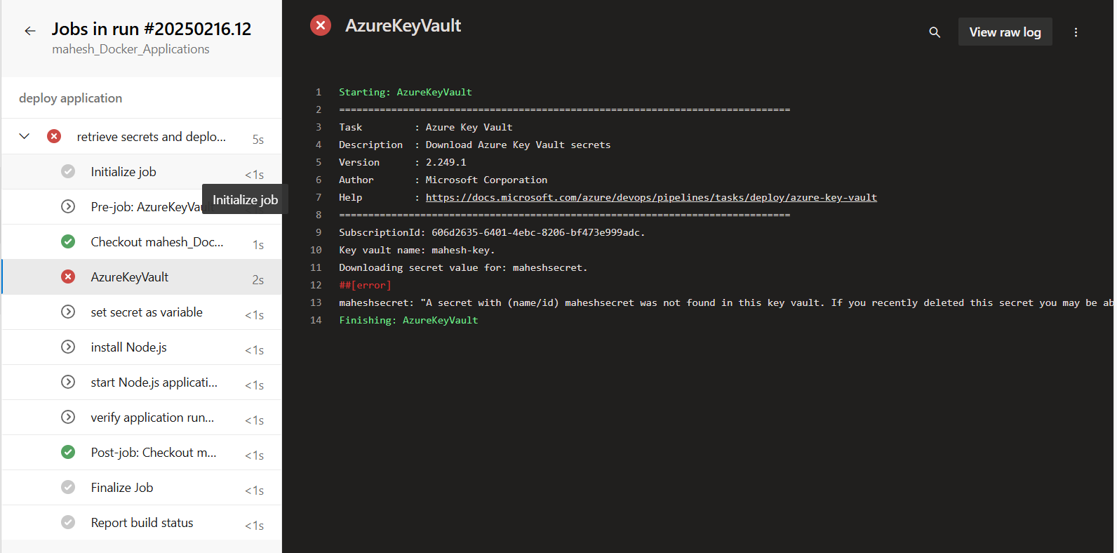

* **Fixed pipeline.yml**

trigger:

- main

pool:

name: 'self-hosted-server'

variables:

keyVaultName: "mahesh-key"

secretName: "maheshsecret"

stages:

- stage: Deploy

displayName: deploy application

jobs:

- job: RetrieveSecrets

displayName: retrieve secrets and deploy Node.js app

steps:

- task: AzureKeyVault@2

inputs:

azureSubscription: 'maheshkeyvaultconnection-v2'

KeyVaultName: $(keyVaultName)

SecretsFilter: $(secretName)

- script: |

echo "retrieving secret"

if [ -z "$(maheshsecret)" ]; then

echo "##vso[task.logissue type=error]Secret retrieval failed: maheshsecret is empty"

exit 1

fi

echo "##vso[task.setvariable variable=MY_SECRET;issecret=true]$(maheshsecret)"

displayName: 'set secret as variable'

- task: UseNode@1

inputs:

version: '16.x'

displayName: 'install Node.js'

- script: |

echo "deploying Node.js app"

KEYVAULT_NAME=$(keyVaultName) \

SECRET_NAME=$(secretName) \

MY_SECRET=$(MY_SECRET) \

nohup node server.js > app.log 2>&1 &

displayName: 'start Node.js application'

- script: |

echo "checking if Node.js app is running"

sleep 5

ps aux | grep node

sudo netstat -antp | grep 3000 || echo "Port 3000 is not listening"

displayName: 'verify application running'

* **screenshots of passed pipeline execution**

